EXPERIMENT 2:

BUS TOPOLOGY

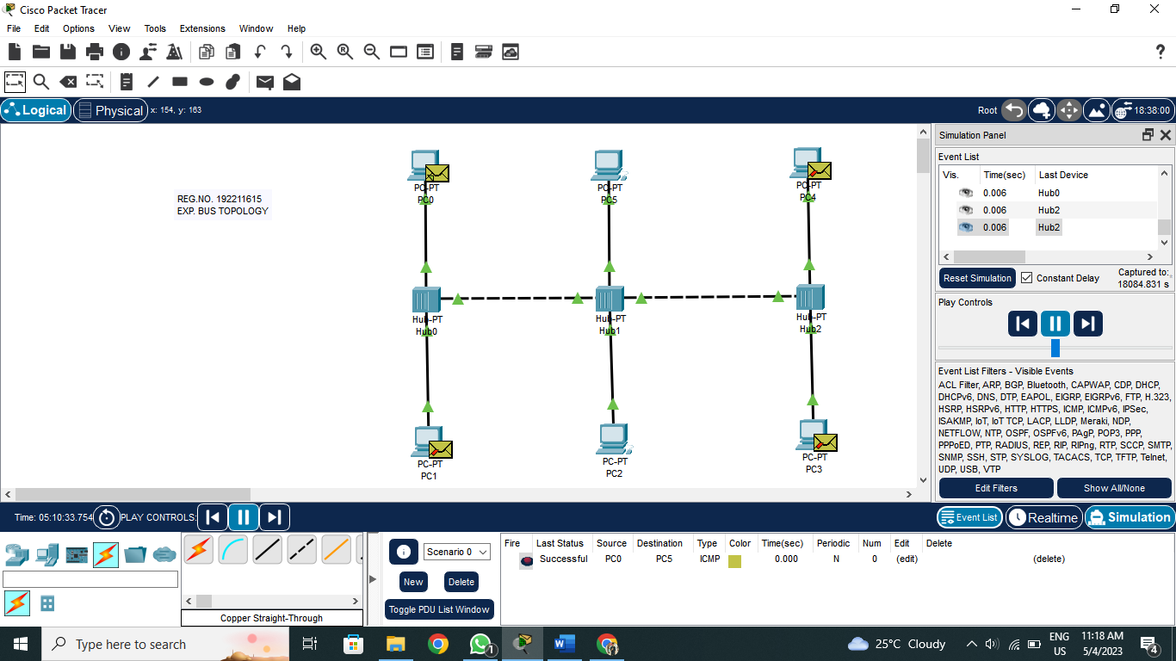

RING TOPOLOGY

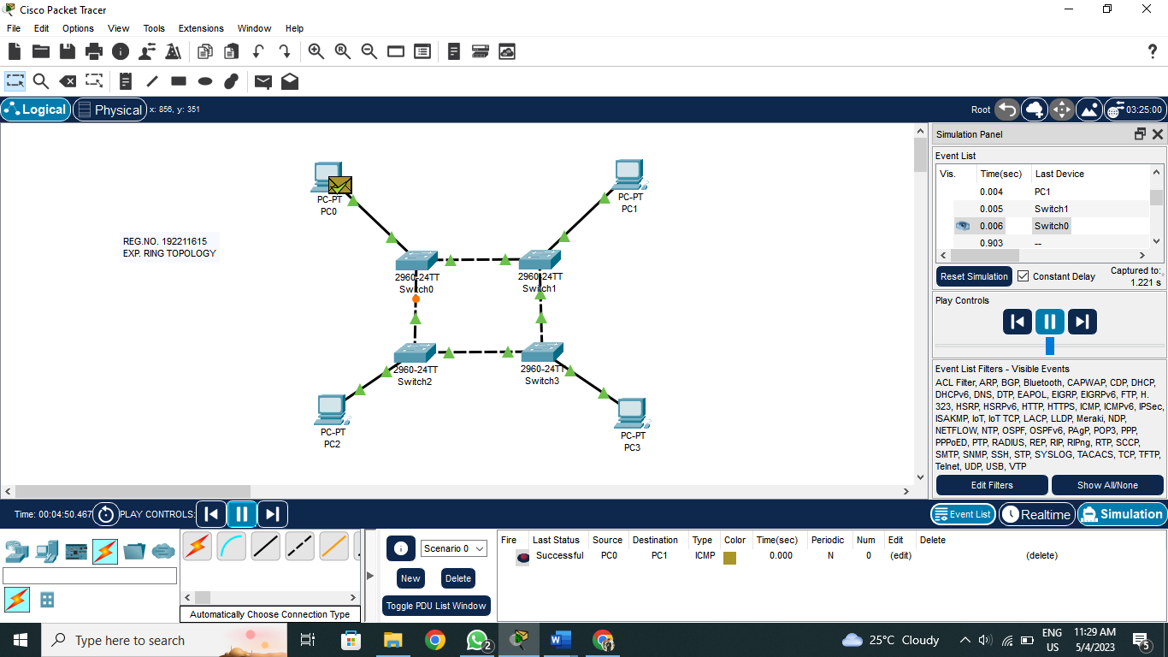

HYBRID TOPOLOGY

